Compass MED D - Pharmacy Locator

Using the PDP Pharmacy Locator Tool
Using the EGWP Pharmacy Locator Tool
Preferred Pharmacy Network Search in Compass
Resolution Time
Related Documents

Description: This document provides guidance to the CCR on how to access and use the Pharmacy Locator Tool.

Using the PDP Pharmacy Locator Tool

In order to utilize the Pharmacy Locator Tool to locate a pharmacy in the beneficiary’s area, the CCR will:
Step | Action
1 | Access https://aetnamedicare.com/ and follow the steps below:  - Scroll to the bottom of the home page and select Find a Pharmacy under Helpful Links  Notes:  - Many SilverScript EGWP clients have microsites. Refer to the CIF to ensure the correct site is used to locate pharmacies.  Exception: For AT&T EGWP, the CCR should use Caremark.com under the beneficiary’s profile.  - For Aetna/MED D EGWP clients proceed to Aetnamedicare.com EGWP Pharmacy Locator Tool
2 | Enter beneficiary’s Zip Code.  Notes:  - The website may ask for the user to clarify the county of residence.  - If a beneficiary cannot provide a Zip Code or just has general questions about the pharmacy network, use the Preferred Pharmacy Network Search in PeopleSafe section to assist them.
3 | Select Find a 2026 pharmacy in our network.  Note: Select Request a printed copy of your directory if applicable. Refer to MED D - Digital Evidence of Coverage, Formulary and Pharmacy Directory.  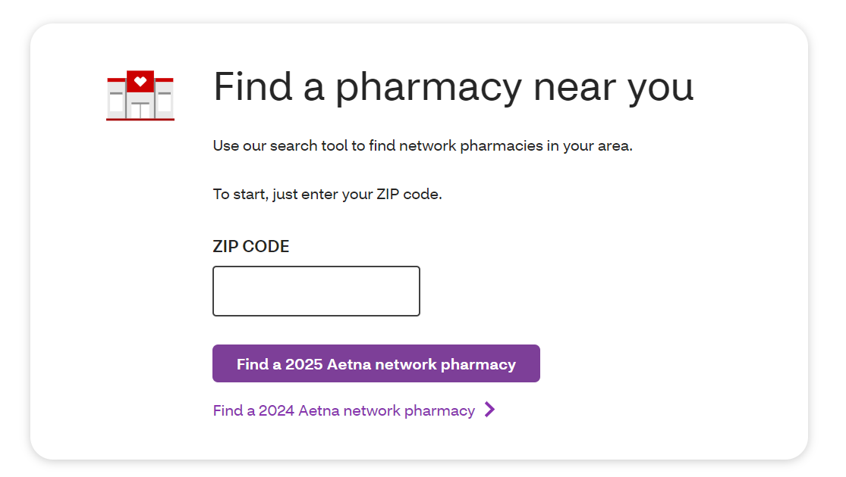
4 | Select Prescription Drug Plans to locate the beneficiary’s pharmacies.  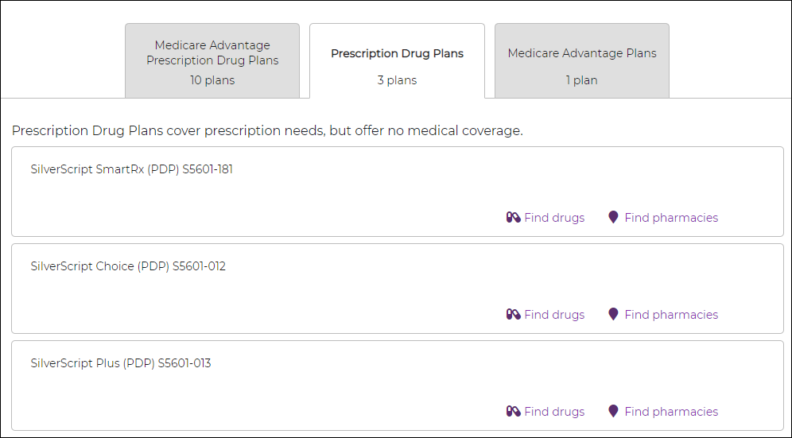
5 | Select Find Pharmacies under appropriate Prescription Drug Plan.  Result: The Pharmacy Locator will display a list of all pharmacies, including a map, in the beneficiary’s area which can be used with his/her SilverScript Medicare Part D plan.  - Only 10 pharmacies per page are displayed.  - In order to view the others on the list, click on the Next hyperlink at the bottom of the search results.  - The following information will be displayed:  - Pharmacy Name  - Address  - Pharmacy Type  - Preferred or Standard In-network  Note: Preferred In-network pharmacies are designated by an orange tag, while Standard In-network pharmacies are designate by a teal tag.  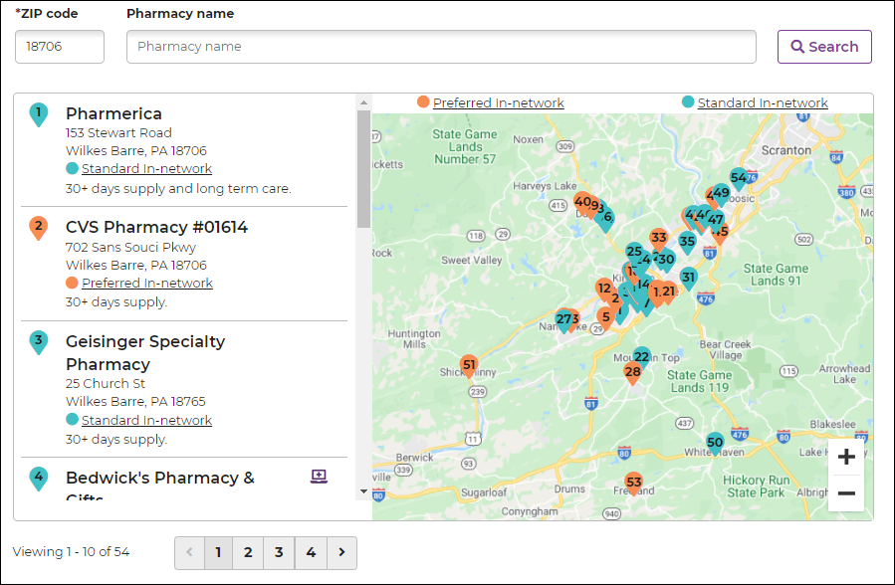
6 | Provide the beneficiary with pharmacy information.  Do NOT proactively offer to fulfill a list of pharmacies in the beneficiary’s area unless it’s requested.
6 | If the beneficiary… | Then…
6 | Requests a printout of pharmacies in his/her area | Refer to the MED D - Fulfillment Request work instruction.
6 | Does not request a printout | Proceed to Step 7.

Top of the Document

Using the EGWP Pharmacy Locator Tool

Perform the steps below:
Step | Action
1 | Access https://health.aetna.com/ahpublic/medicare-direct and follow the steps below:  - Enter the Zip Code or County and the Plan Year.  - Select Employer or group-sponsored retiree plan.  - Select See Plans.  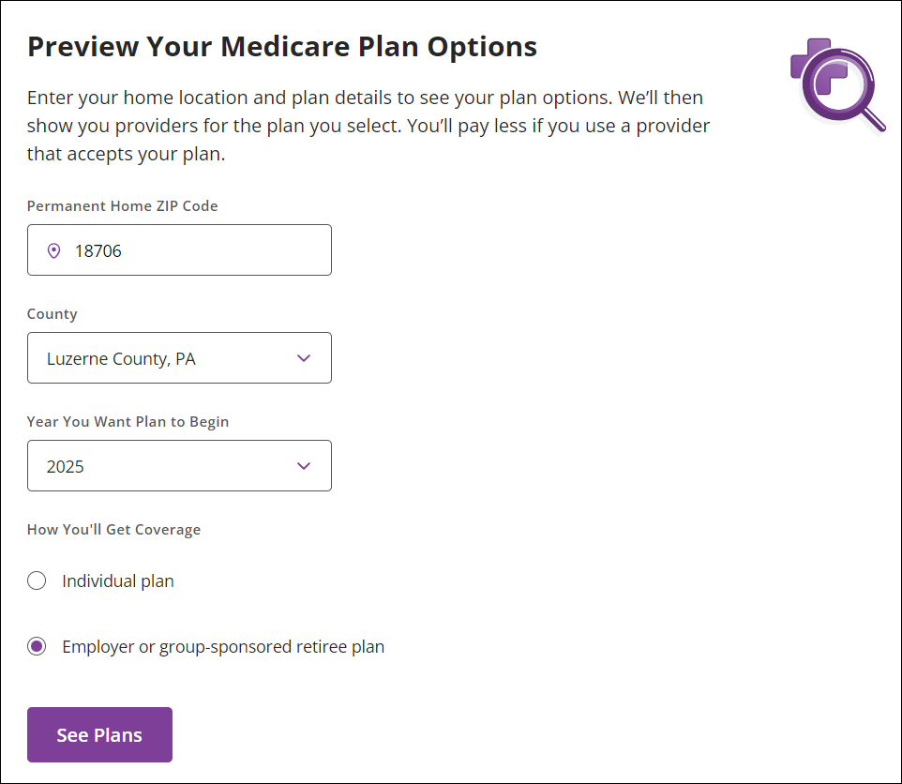
2 | Scroll down to the Prescription Drug Plans section of the page that displays.  - Select the Pharmacy Plan.  - Select View Care Options to see the network pharmacies.  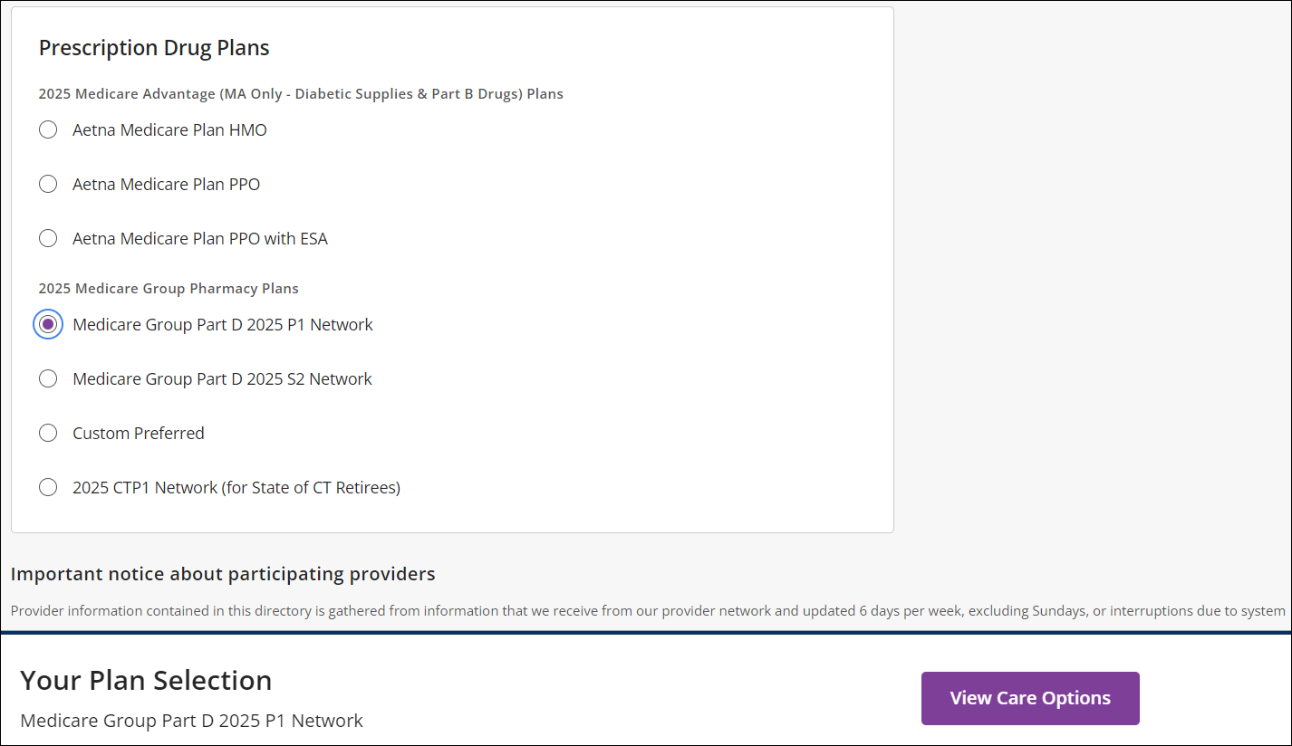
3 | Determine if the beneficiary’s pharmacy networks are listed.  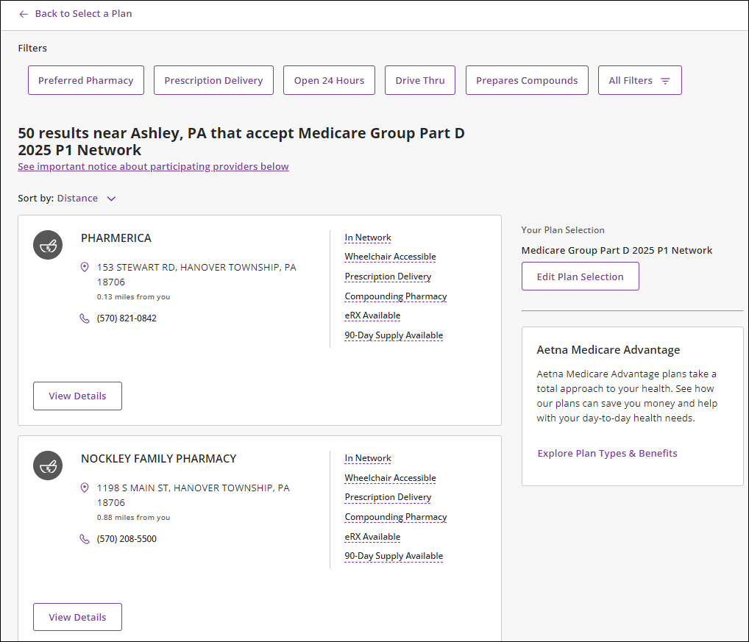
3 | If… | Then…
3 | Yes | Provide the information to the beneficiary.
3 | No | Review the list and provide other pharmacies that are available in the beneficiary’s area.

Top of the Document

Preferred Pharmacy Network Search in Compass

CCRs will be able to locate preferred and/or standard pharmacies based upon the beneficiary’s pharmacy benefit plan type and the appropriate pharmacy network.

Use the table below to identify if the beneficiary has a preferred pharmacy network using any of these areas in Compass:
Screen | Action
Client Program Offerings | From the Claims Landing Page, navigate to the Quick Actions panel and click the Client Program Offerings hyperlink.  Result: The Available Client Program Offerings screen displays.  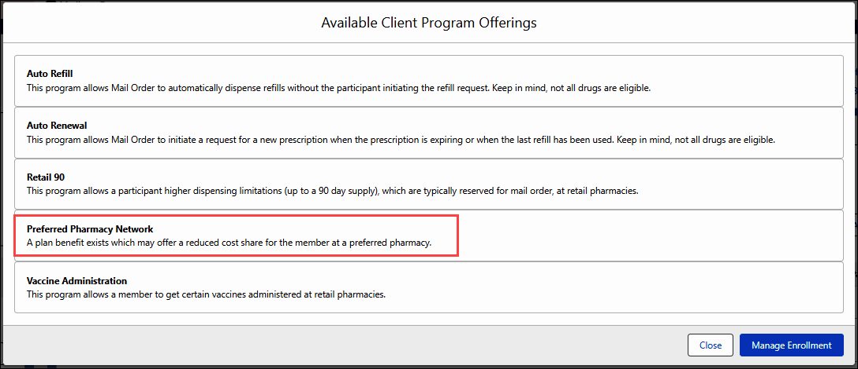  Note: If the client has elected Preferred Pharmacy Network and Retail 90, this means that the beneficiary will have a choice to use Standard or Preferred pharmacies in their network. There are cost advantages to filling their prescriptions at a Preferred Pharmacy.
Pharmacy Search | From the Claims Landing Page or the Member Snapshot Landing Page, navigate to the Quick Actions panel and click the Pharmacy Search hyperlink.  Result: A new tab opens, and the Find a Pharmacy screen displays.  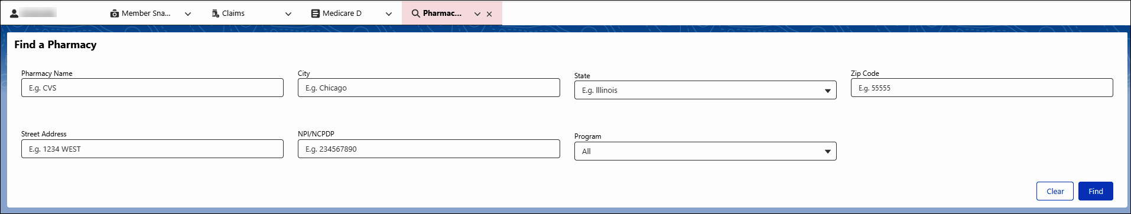
Pharmacy Details Screen | After locating the correct Pharmacy from the Find a Pharmacy screen, click the Pharmacy Name hyperlink.  Result: The Pharmacy Details screen displays.  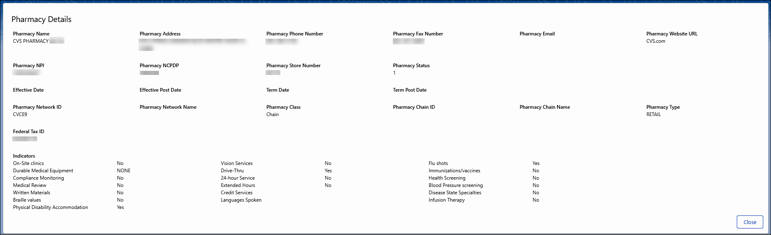
Test Claim Pharmacy Screen | On the bottom right of the List of Test Claims to Run section, the selected Pharmacy will show as being “In Network.” Click the Change Pharmacy button.  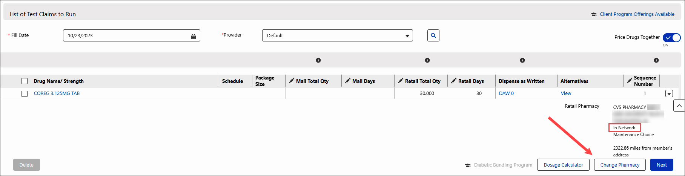  Result: The Select Test Claim Pharmacy screen displays.

Top of the Document

Resolution Time
Immediate.

Top of the Document

Related Documents
Parent SOP: CALL-0048: Medicare Part D Customer Care Call Center Requirements-CVS Caremark Part D Services, L.L.C.
Abbreviations/Definitions: Customer Care Abbreviations, Definitions, and Terms Index

Top of the Document
Not to Be Reproduced or Disclosed to Others without Prior Written Approval
ELECTRONIC DATA = OFFICIAL VERSION - PAPER COPY = INFORMATIONAL ONLY

